

# School of Computing

**SRM IST, Kattankulathur – 603 203**

**Course Code: 18CSC206J**

**Course Name: Software Engineering and Project Management**

|  |  |
| --- | --- |
| **Experiment No** | 5 |
| **Title of Experiment** | Prepare Work breakdown structure, Timeline chart, Risk identification table |
| **Name of the candidate** | Shaurya Singh Srinet |
| **Team Members** | Shounak Chandra, Parth Galhotra |
| **Register Number** | RA2111032010006, RA2111032010026, RA2111032010029 |
| **Date of Experiment** | 21.02.2023 |

**Mark Split Up**

|  |  |  |  |
| --- | --- | --- | --- |
| **S. No** | **Description** | **Maximum Mark** | **Mark Obtained** |
| 1 | Exercise | 5 |  |
| 2 | Viva | 5 |  |
| **Total** | | **10** |  |

# Staff Signature with date

## Aim:

To Prepare Work breakdown structure, Timeline chart and Risk identification table

## Team Members:

|  |  |  |  |
| --- | --- | --- | --- |
| **Sl No** | **Register No** | **Name** | **Role** |
| **1** | **RA2111032010006** | **Shaurya Singh Srinet** | **Rep/Member** |
| **2** | **RA2111032010026** | **Shounak Chandra** | **Member** |
| **3** | **RA2111032010029** | **Parth Galhotra** | **Member** |

**WORK BREAKDOWN STRUCTURE:**

The WBS is a view into the project that illustrates the work the project encompasses. The Project Manager and project team use the WBS to develop the project schedule, resource requirements, and costs.

1. Library Management System (Deliverable) scope
   1. Basic Desktop level Application Frame
      1. Entry Page
         1. Login Tab
         2. Signup Tab
         3. Terms and Conditions Hyperlink
         4. Basic Entry Level Support Hyperlink
      2. Home page
         1. Dashboard tab
         2. Help and Support tab
         3. Logout button
         4. Credentials tab
         5. About Us tab
   2. Supporting Project scope
      1. Project Management
      2. Security
      3. Software testing
      4. Documentation

## TREE STRUCTURE VIEW

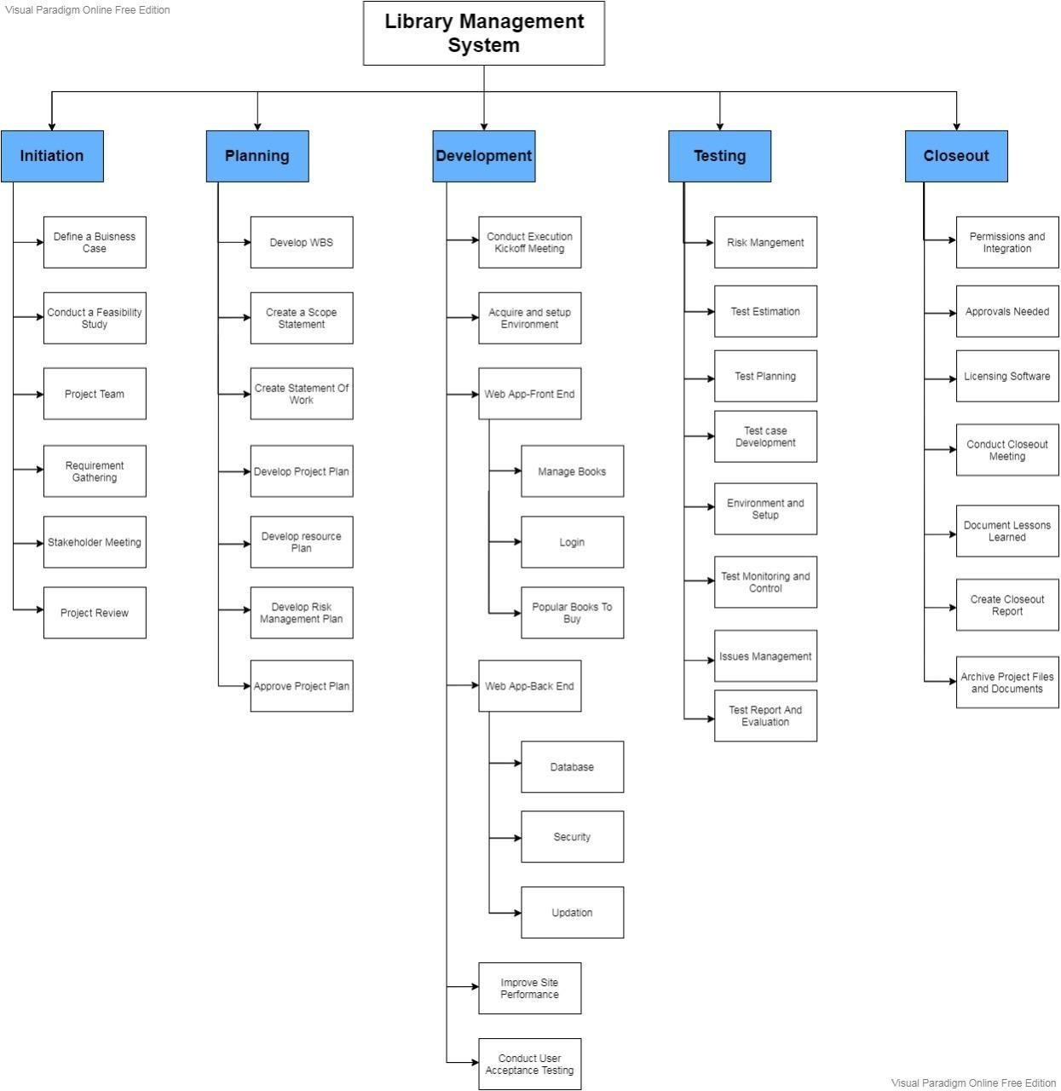

The Tree Structure View is the most popular format for the WBS. It presents an easy-to- understand view into the WBS; however, it is also tricky to create without an application specifically designed for creating this organizational chart structure. The Tree Structure below was created using only Microsoft Word and the SmartArt graphics option under the insert menu.

## TIMELINE – GANTT CHART

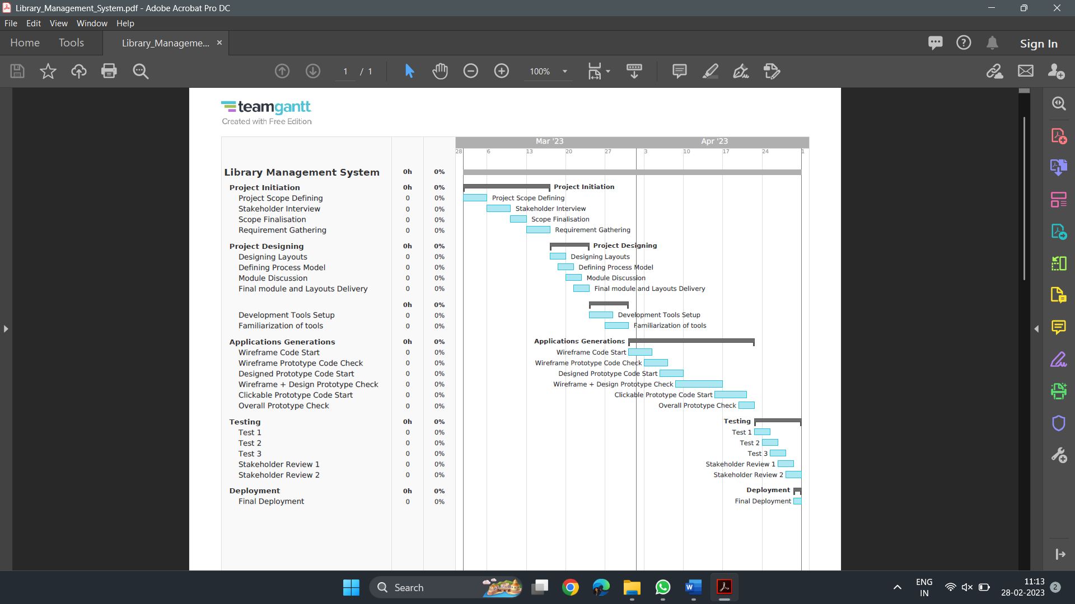

**RISK ANALYSIS – SWOT & RMMM**

## SWOT Analysis:

|  |  |
| --- | --- |
| **Strengths**   * Efficient management of library resources * Improved user experience * Automation of library tasks * Accurate reporting | **Weaknesses**   * Initial implementation costs * Technical issues * Dependence on technology * Limited flexibility |
| **Opportunities**   * Integration with other systems * Cloud-based systems * Mobile accessibility * E-books and digital media | **Threats**   * Budget constraints * Competition from other libraries * Security threats * Resistance to change |

**RMMM Risk Table:**

The risks are categorized based on their likelihood and potential impact, with high-risk events requiring more attention and mitigation strategies. Mitigation strategies may include regular maintenance and equipment replacement planning, security audits and updates, backup systems in place, staff training on data protection, and contingency plans.

|  |  |  |  |  |
| --- | --- | --- | --- | --- |
| **Level of Risk** | **Description** | **Likelihood** | **Impact** | **RMMM Plan** |
| High | Major security breach | High | High | Regular security audits and updates, encryption of sensitive data, staff training on data protection |
| Medium | Major equipment Failure | Medium | High | Regular maintenance and equipment replacement planning, backup systems in place, contingency plans |
| Medium | Loss of library materials | Medium | Medium | Regular inventory checks, security measures to prevent theft, backup copies or digitization of important materials |
| Low | Staff Shortage | Low | Low | Cross-training of staff, flexible scheduling, recruitment, and retention strategies |
| Low | Minor equipment failure | Low | Low | Regular maintenance and repair, backup systems in place |
| Low | Minor security breach | Low | Low | Regular security audits and updates, staff training on data protection |

## Result:

Thus, the work breakdown structure with timeline chart and risk table were formulated successfully